Day 1: Introduction to R programming
Session 1: Introduction to Stata and Data Import
  - Installing R and RStudio
Feature | R | Python | STATA | SPSS
License | Free and open-source | Free and open-source | Proprietary | Proprietary
User Interface | Command-line, IDEs (RStudio) | Command-line, IDEs (Jupyter, PyCharm) | Graphical user interface (GUI) | Graphical user interface (GUI)
Visualization | Extensive libraries (ggplot2) | Extensive libraries (matplotlib, seaborn) | Basic | Basic
Type | Statistical Analysis | General Purpose Language | Statistical Analysis | Statistical Analysis
Community Support | Large, active community | Large, active community | Smaller, specialized | Moderate
Cost | Free | Free | Paid | Paid
Learning Curve | Steep | Moderate | Relatively easy | Relatively easy
Flexibility | High | High | Moderate | Moderate

 | https://www.r-project.org/
 | https://posit.co/download/rstudio-desktop/

  - Starting to work with R and RStudio
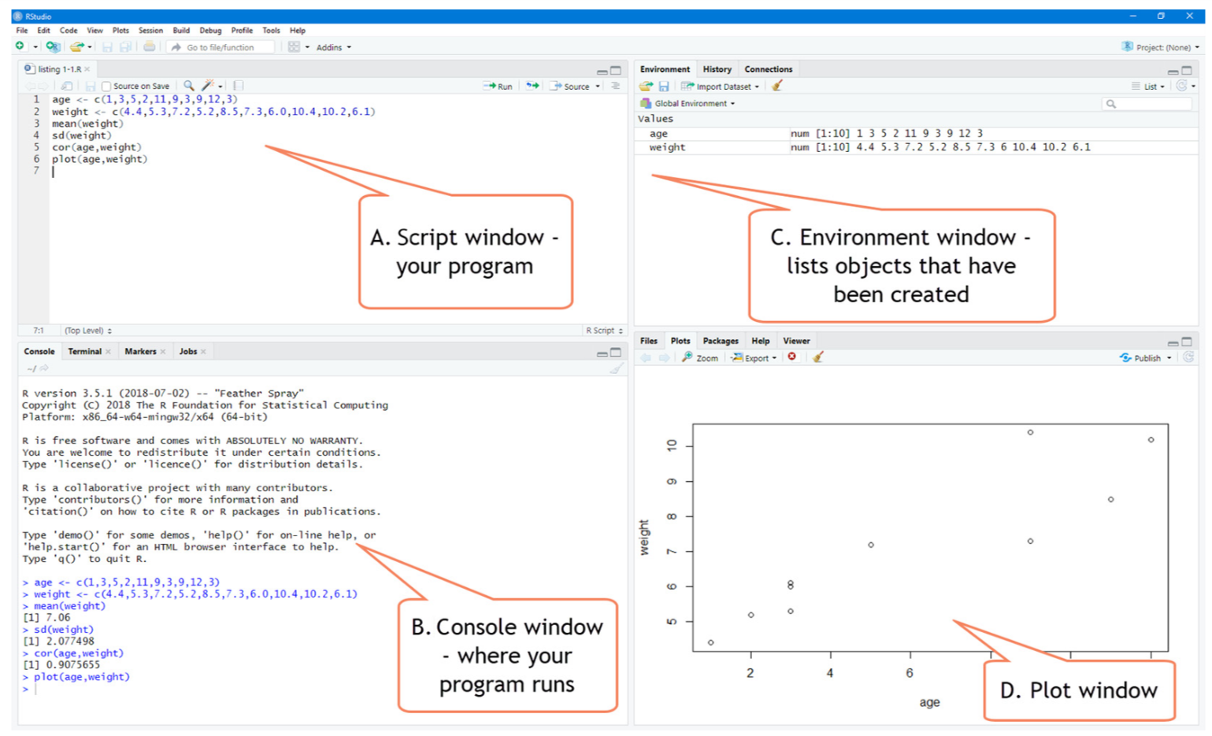

Setting working environment
E001-setting_working_directory.R
#checking the current working directory
getwd()

#setting the new working directory
setwd('G:/.shortcut-targets-by-id/1ASYiYxEAcgJNzEL19Ex5oWLpC3ekSV7j/ROOT/TSM/to be delivered/training delivered/R training NSO')

Starting to work with R
E002-starting_with_R.R
#creating dummy dataset
age <- c(1,3,5,2,11,9,3,9,12,3)
weight <- c(4.4,5.3,7.2,5.2,8.5,7.3,6.0,10.4,10.2,6.1)

#calculating mean weight
mean(weight)

#calculating standard deviation of weight
sd(weight)

#calculating correlation between age and weight
cor(age, weight)

#plotting age and weight
plot(age, weight)

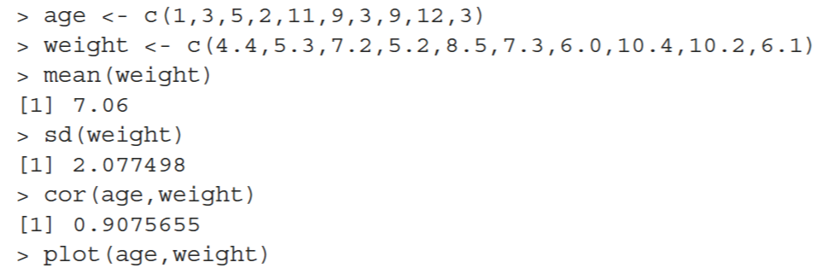

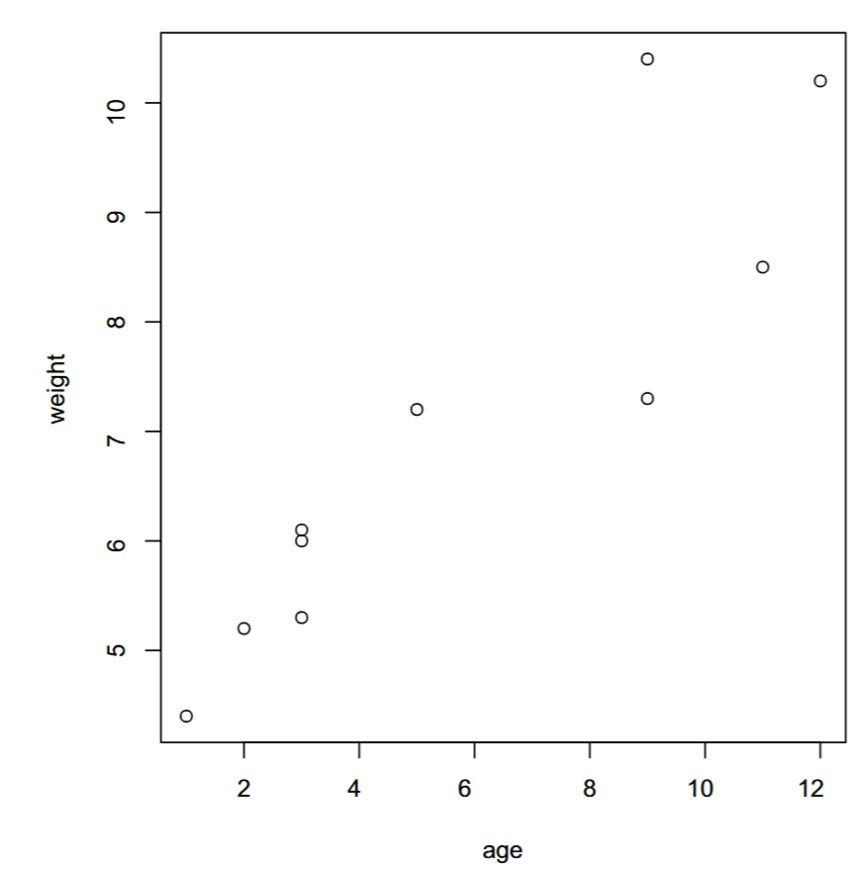

Getting help
E003-getting_help.R
#general help
help.start()

#help on a function
help('lm') #OR
?lm

#help on a package
help(package = 'stats')

#Searches the help system for instances of the given string
help.search('correlation') #OR
??correlation

#Examples of given function
example('lm')

#Lists all available example datasets contained in currently loaded packages
data()

#listing and exploring a particular vignette (detailed help file with tutorial and examples)
vignette()
vignette('ggplot2')

Package management
E004-package_management.R
#installing a package
install.packages('plotly')

#loading a package
library(plotly)

#printing package information
packageDescription('plotly')
help(package = 'plotly')

#using the loaded package
plot_ly(x = 2001:2020, y = (1:20)^2, type = 'bar')

#removing a package
remove.packages('plotly')

Task 1:
- Open the general help and look at the Introduction to R section.
- Install the vcd package.
- Load the package and read the description of the dataset Arthritis.
- List the available dataset.
- Print out the Arthritis dataset.
- Run the example that comes with the Arthritis dataset.

#1. Open the general help and look at the Introduction to R section.
help.start()

#2. Install the vcd package.
install.packages("vcd")

#3. List the available dataset.
data(package = 'vcd')

#4. Load the package and read the description of the dataset Arthritis.
library(vcd)
help(Arthritis)

#5. Print out the Arthritis dataset.
Arthritis

#6. Run the example that comes with the Arthritis dataset.
example(Arthritis)

Session 2: Data objects
  - Data structures in R
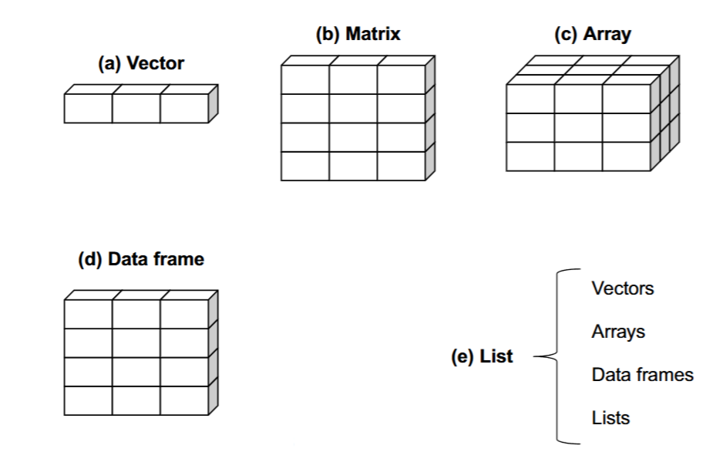

Vector
Vectors are one-dimensional arrays that can hold numeric data, character data, or logical data.
E005-vector.R
a <- c(11,22,33,44,55)
b <- c('one','two','three')
c <- c(TRUE, FALSE, FALSE)

#accessing vector elements
a[4]
b[c(1,3)]
a[3:5]

#modifying an element
a[1] <- 99
a

#removing an object
rm(a)

Matrix
E006-matrix.R
x <- c(1,2,3,4,5,6,7,8)

#creating a matrix (by default byrow == FALSE)
m1 <- matrix(x, nrow = 2, ncol = 4)
m1
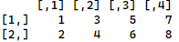

#creating a matrix with byrow = TRUE
m2 <- matrix(x, nrow = 2, ncol = 4, byrow = TRUE)
m2
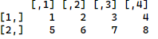

#--------------------------
#accessing elements of a matrix
#--------------------------
m2[1,] #selecting the first row

m2[,3] #selecting the third column

m2[2,c(3,4)] #selecting the 3rd and 4th element of the 2nd row

#--------------------------
#basic matrix operations
#--------------------------
m1 + m2 #addition
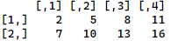

m1 - m2 #subtraction
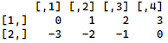

t(m1) #transpose
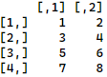

t(m1) %*% m2 #matrix dot product
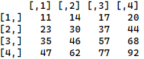

mm <- matrix(c(1,2,3,4), nrow = 2)
mm
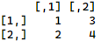

det(mm) #determinant of a matrix
solve(mm) #inverse of a matrix
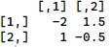

Dataframe
A data frame is more general than a matrix in that different columns can contain different modes of data (numeric, character, and so on). It’s similar to the dataset you’d typically see in Stat.
E007-dataframe.R
#-------------------------------
#creating a dataframe
#-------------------------------
id <- c(1,2,3,4)
age <- c(25,34,28,52)
sex <- c(0,1,1,0) #0 - female, 1 - male
diabetes <- c("Type1", "Type2", "Type2", "Type1")
status <- c("Poor", "Improved", "Excellent", "Poor")

df <- data.frame(id, age, sex, diabetes, status)
df
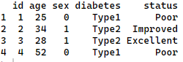

#-------------------------------
#accessing a column
#-------------------------------
df[,2] #accessing the column values by index
df$age #accessing the column values by name
df["age"] #accessing the column by name
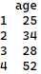

#-------------------------------
#accessing a multiple columns
#-------------------------------
df[,c(1,3,4)] #accessing the columns by index
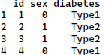
df[c("id","status")] #accessing the columns by name
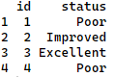

#-------------------------------
#creating a frequency twoway table
#-------------------------------
table(df$diabetes, df$status)
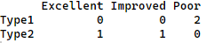

#-------------------------------
#Converting sex column to a factor (categorical) type
#-------------------------------
df$sex <- factor(df$sex, levels = c(1,0), labels = c("Male", "Female"))
df$diabetes <- factor(df$diabetes)

df
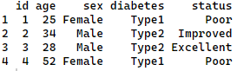

df$sex
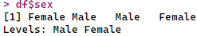

df$diabetes
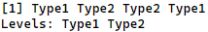

#-------------------------------
# Variable labeling
#-------------------------------
attr(df$id, "label") <- "Patient ID"
attr(df$age, "label") <- "Patient Age in years"
attr(df$sex, "label") <- "Patient sex"
View(df)
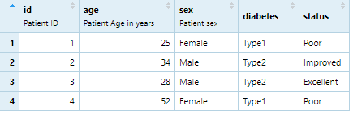

#removing a label
attr(df$sex, "label") <- NULL
View(df)
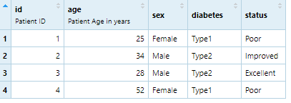

List
A list is an ordered collection of R objects
E008-list.R
g <- "My First List"
h <- c(25, 26, 18, 39)
j <- matrix(1:10, nrow=5)
k <- c("one", "two", "three")

mylist <- list(title=g, ages=h, j, k)
mylist
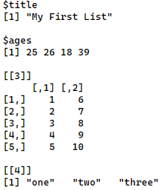

#-------------------------------
#accessing an object
#-------------------------------
mylist$title #by object name in the list

mylist[['ages']] #by object name in the list

mylist[[1]] #by index number

  - Data input

Data input using keyboard (manual)
E009-data_input_keyboard.R
#---------------------------------------------------------------------
# Creating a new dataframe with data input using keyboard
#---------------------------------------------------------------------
df <- edit(data.frame())
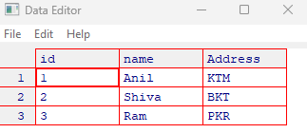

#---------------------------------------------------------------------
# Editing an existing dataframe
#---------------------------------------------------------------------
fix(df)

Importing data from various sources
E010-data_import.R
#---------------------------------------------------------------------
# Importing data from a delimited text file (e.g. csv)
#---------------------------------------------------------------------
df1 <- read.table('data/001-Arthritis.csv', header = T, sep = ',')
# OR
df2 <- read.csv('data/001-Arthritis.csv')

# Checking data structure (variable types)
str(df1)
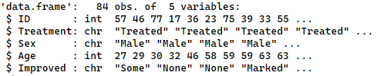

#---------------------------------------------------------------------
# Importing data from excel file
#---------------------------------------------------------------------
library(readxl) #install the package if not installed
df3 <- read_xlsx('data/002-excel_data.xlsx', sheet = 'Orange')
df4 <- read_xlsx('data/002-excel_data.xlsx', sheet = 'infert')

#---------------------------------------------------------------------
# Importing data from SPSS and Stata
#---------------------------------------------------------------------
library(haven)
df5 <- read_spss('data/003-mn.sav')
df6 <- read_stata('data/004-campus.dta')

#---------------------------------------------------------------------
# Importing files directly from the web
#---------------------------------------------------------------------
df7 <- read.csv('https://people.sc.fsu.edu/~jburkardt/data/csv/biostats.csv')

Session 3: Data management
  - Data management using dplyr package

Rows operations
E011-dplyr_operation_rows.R
#---------------------------------------------------------------------
# Import datasets
#---------------------------------------------------------------------
classf <- read.csv('data/005-wb_class.csv')
energy <- read.csv('data/006-wb_energy.csv')
var_def <- read.csv('data/007-wb_energy_var_def.csv') #variable definition

#---------------------------------------------------------------------
# Rows operation
#---------------------------------------------------------------------
# *** filter ***
library(dplyr)
data_nepal <- filter(energy, country == 'Nepal')
data_nepal
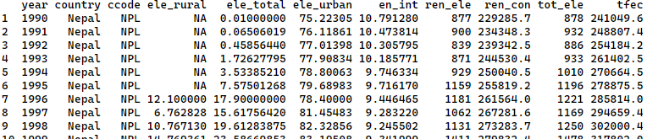

filter(energy, country == 'Nepal' & year > 1999)
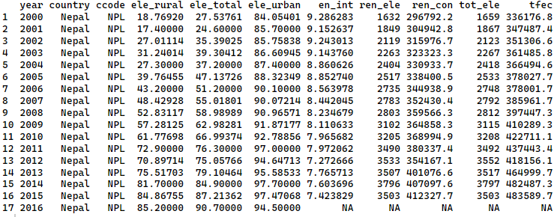

# *** arrange ***
arrange(energy, desc(country), tot_ele)
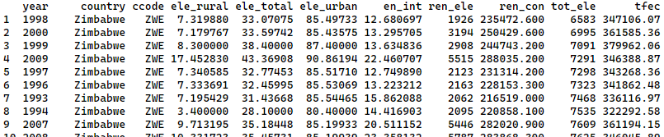

# *** na.omit ***
na.omit(energy)

# *** slice *** : used to choose rows using their position
slice(energy,3:7)
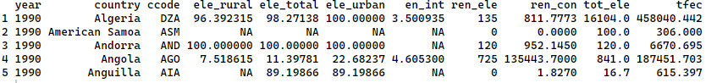

slice_head(energy, n = 3)
#OR
head(energy, n = 3)

slice_tail(energy, n = 3)
#OR
tail(energy, n = 3)

slice_sample(energy, n = 5) #randomly selects 5 observations (rows)
slice_sample(energy, prop = 0.01) #selects 1% sample randomly
slice_sample(energy, prop = 0.01, replace = T) #selects 1% sample randomly with replacement

Columns operations
E012-dplyr_operation_columns.R
#---------------------------------------------------------------------
# Columns operation
#---------------------------------------------------------------------
# *** select ***
select(energy, year, ccode, tot_ele) #selects year, ccode, and tot_ele
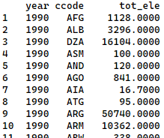

select(energy, year:ccode) #selects columns from year to ccode
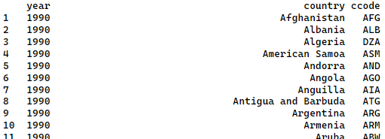

select(energy, !(year:ccode)) #selects columns other than from year to ccode
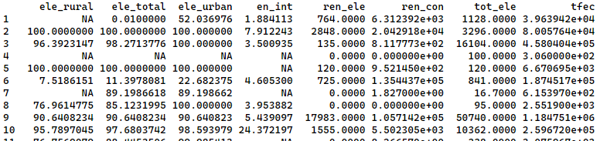

head(select(energy, contains('tot'))) #selects columns with names that contains tot
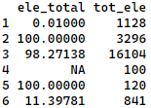

head(select(energy, starts_with('ele'))) #selects columns with names that starts with ele
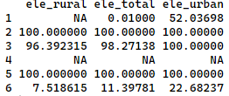

head(select(energy, ends_with('ele'))) #selects columns with names that ends with ele
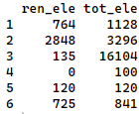

# *** rename ***
head(rename(energy, year_AD = year))
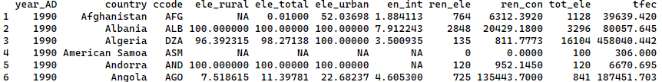

# *** mutate ***
head(mutate(energy, ren_ele_share = ren_ele/tot_ele * 100))
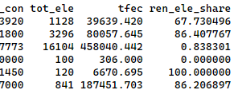

Piping (%>%) : Piping is used for chaining multiple operations together in a clean way.

Suppose the goal is to take a list of numbers, find the absolute difference between them,
calculate the mean of those differences, and round the result at 1 decimal place.

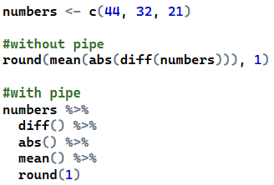

Example: Suppose you are interested in renewable electricity output data in Nepal and India. Now, you want to perform the following operations with the help of piping (%>%).
- Select columns year, country, ren_ele, tot_ele from energy dataframe.
- Keep data of Nepal and India only.
- Sort the dataframe according to country and year columns.
- Create a new column ren_ele_share by calculating share of renewable electricity output in total output (i.e. ren_ele/tot_ele*100).
- Save the new dataframe as energy_np_in
E013-dplyr_piping.R
energy_np_in <- energy %>%
select(year, country, ren_ele, tot_ele) %>% # Select columns year, country, ren_ele, tot_ele
filter(country == 'Nepal' | country =='India') %>% # Keep data of Nepal and India only
arrange(country, year) %>% # Sort the dataframe according to country and year columns
mutate(ren_ele_share = ren_ele/tot_ele*100) # Create a new column ren_ele_share
View(energy_np_in)

Summarizing by categories using group_by() and summarize() functions.
Example: Suppose now you want to summarize the dataframe energy_np_in by calculating max, min, and average values of ren_ele_share in Nepal and India and save summarized dataframe as energy_summary.
E014-dplyr_summarize.R
energy_summary <- energy_np_in %>%
na.omit() %>%
group_by(country) %>%
summarize(max = max(ren_ele_share),
min = min(ren_ele_share),
mean = mean(ren_ele_share))

View(energy_summary)

Task 2:
Let’s summarize the dataframe energy by calculating max, min, and average values of ele_total [Access to electricity (% of total population)] in each year.

df_summary <- energy %>%
na.omit() %>%
group_by(year) %>%
summarize(max = max(ele_total),
min = min(ele_total),
mean = mean(ele_total))

df_summary

Session 4: Data management (Continued)
  - Merging datasets

E015-joins.R
df1 <- data.frame(id = c(1, 2, 3), colA = c("A", "B", "C"))
df2 <- data.frame(id = c(1, 3, 5), colB = c("X", "Y", "Z"))
print(df1)
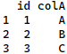

print(df2)
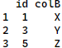

inner_join(df1, df2, by = 'id') #Return rows with matching keys in both data frames
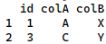

left_join(df1, df2, by = 'id') #Return all rows from first data frame, matching rows from second
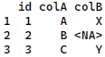

right_join(df1, df2, by = 'id') #Return all rows from second data frame, matching rows from first
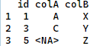

full_join(df1, df2, by = 'id') #Return all rows from both data frames, matching by keys
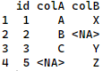

Task 3:
- Let’s left_join dataframes energy and classf by common column ccode.
- Summarize by calculating average values of ele_total [Access to electricity (% of total population)] for each year and country group (i.e., H, UM, LM, L).
- Save the summarized dataframe as wb_energy.
wb_energy <- left_join(energy, classf, by = 'ccode') %>%
na.omit() %>%
group_by(year, wb_class) %>%
summarize(average = mean(ele_total))
View(wb_energy)

Task 4:
- Load "data/008-nlfs2.dta" dataset and store it in nlfs2 dataframe.
- From nlfs2, create a dataframe of family size named fsize.
- Merge dataframes nlfs2 and fsize. Then replace the nlfs2 dataframe with the merged dataframe.
- Keep columns psu, hhid, family_size, q10, q09.
- Rename q10 to age, q09 to gender.

library(haven)
library(dplyr)
nlfs2 <- read_stata('data/008-nlfs2.dta') #nlfs2 data with 50 percent data

fsize <- nlfs2 %>%
count(psu, hhid) %>%
rename(family_size = n)
# OR
fsize <- nlfs2 %>%
group_by(psu, hhid) %>%
summarize(family_size = n())

nlfs2 <- full_join(nlfs2, fsize, by = c('psu','hhid'))

nlfs2 <- nlfs2 %>%
select(psu, hhid, family_size, q10, q09) %>%
rename(age = q10, gender = q09)

  - Conditional data generation
Based on the above nlfs2 dataframe, lets create the following columns with the conditions.
- Generate a column family_size_group ( small <= 2, medium <=4, large >= 5)
- age_group (teen <= 20, adult <=60, old >= 61)
- male (1 if male, 0 if female). Then convert the male to a factor variable with appropriate labels (1 – Male, 0 -- Female).
E016-case_when.R
nlfs2 <- nlfs2 %>%
mutate(family_size_group = case_when(family_size <= 2 ~ 'Small',
family_size <= 4 ~ 'Medium',
family_size >= 5 ~ 'Large')) %>%
mutate(age_group = case_when(age <= 20 ~ 'Teen',
age <= 60 ~ 'Adult',
TRUE ~ 'Old')) %>%
mutate(male = case_when(gender == 2 ~ 0,
gender == 1 ~ 1)) %>%
mutate(male = factor(male, levels = c(1,0), labels = c('Male', 'Female')))

  - Exporting a dataframe to csv, excel, RData, dta files.
E017-exporting_dataframe.R
#----------------------------------------------------------------------
# Exporting dataframe to a csv file
#----------------------------------------------------------------------
write.csv(fsize, file = 'fsize.csv', row.names = F)

#----------------------------------------------------------------------
# Exporting dataframe to a excel file
#----------------------------------------------------------------------
library(openxlsx)
write.xlsx(fsize, file = "fsize.xlsx")

#----------------------------------------------------------------------
# Exporting dataframe to a RData file
#----------------------------------------------------------------------
save(fsize, file = 'fsize.RData')
load('fsize.RData')

#----------------------------------------------------------------------
# Exporting dataframe to a dta (Stata) file
#----------------------------------------------------------------------
library(haven)
write_dta(fsize, path = 'fsize.dta')

